

Crossroads   
Release Notes

Release 6.28.10 [PR_3629]

Revision 1.0

08/10/2014

**Code Release Checklist**

Product/Application/Service: Crossroads

Release Notes: __X__

Build Kit Identification: _Crossroads6.28.10 _________________

Directory/Table changes required: None

Scheduled Release Date: 08/10/2014

OS release is being tested with: Linux

OS patch version level _RHEL5.6 2.6.18-238.5.1.el5

Third party software version:

System Test: Development:

Iplanet Web Server 7 SP6 Iplanet Web Server 7 SP6

Iplanet Directory Server 5.2 Iplanet Directory Server 5 SP2

Proxy Server: OHS 11.1.1.7/ Proxy Server: OHS 11.1.1.5/

Apache 2.2.15 Apache 2.2.15

Java JDK 1.6.0_24 Java JDK 1.6.0_24

Development Resource On Call:

Name: Gaurav Sharma (Primary)

Phone: 813-610-1082 (Mobile)

813-774-4552 (Home)

Name: Sarath Mani (Secondary)

Phone: 813-484-0016 (Mobile)

813-333-5822 (Home)

Name: Jim Paauw (Secondary)

Phone: 813-493-2467 (Mobile)

727-527-3195 (Home)

Tested

Browser levels _____ IE 8.0 _____

Testing Completed By: _Centralized Test –

Comments: Please list any dependencies that this release may have in relation to other aapplication(s) releases.

VisProactive Diameter :

**Revision History**

|  |  |  |
| --- | --- | --- |
| **Revision Number** | **Date** | **Reason** |
| 1.0 | 08/10/2014 | Initial Release |

**Table of Contents**

1 Release Overview 5

1.1 Overview 5

1.1 VisProactive Diameter 5

1.2 Customer Impact 5

1.3 Processor Impact 5

1.4 Data Impact 5

1.5 Interfacing or Related System Impact 5

1.6 Network Impact 6

1.7 Data Center Impact 6

2 Changes 7

2.1 Tables/Files 7

2.2 Job Processing 7

3 Implementation Tasks 7

3.1 Release Procedures 7

3.1.1 Pre-Release Requirements 7

3.1.2 Crossroads – Director 8

3.2 Backout Procedure 11

3.3 Monitoring/Verification Procedures 11

3.3.1 VisProactive Diameter 11

• Syniverse Company 11

• Syniverse User 12

• Customer Test Company 13

• Customer Test Company User 13

4 Test Procedures 14

# Release Overview

## Overview

This release includes the following:

## VisProactive Diameter [PR_3629]

**The VisProactive Diameter functional design document explains all the functionalities.**

**Here is the Design document link:**

[http://central.syniverse.com/sites/TECH/arch/Crossroads/Release%20Documentation/Crossroads%20Design[VisProactive%20Diameter].docx](http://central.syniverse.com/sites/TECH/arch/Crossroads/Release%20Documentation/Crossroads%20Design%5bVisProactive%20Diameter%5d.docx)

**Note: Please check the Section 3.3 MONITORING/VERIFICATION PROCEDURES for more description and screen-shots.**

Risks

## Customer Impact

None

## Processor Impact

Negligible

## Data Impact

None

## Interfacing or Related System Impact

VisProactive Diameter :

Crossroads release can be installed first, but the VisProactive Diameter related perms will not be available until VisProactive Diameter release is installed.

## Network Impact

None

## Data Center Impact

No additional impact.

# Changes

## Tables/Files

No changes.

## Job Processing

No changes.

# Implementation Tasks

This section describes in detail the steps that need to be performed to install this software release. Each step should be completed and verified before proceeding to the next step. Any queries should be directed to the development team.

## Release Procedures

#### Pre-Release Requirements

##### DNS Requests

##### Request the following DNS entries as CNAMEs to crossroads.syniverse.com:

* vis-diameter.syniverse.com [PROD]

**Functional User ID**

No new functional ID is required.

#### Crossroads – Director

|  |  |
| --- | --- |
|  | **Software Install** |
| Note: | **Crossroads release can be installed first, but the VisProactive Diameter related pod links will not work utill VisProactive Diameter release is installed.** |
|  | **Web Tier – httpd.conf** |
|  | Make backup copies of the httpd.conf files. |
| Step 1 | **Edit the httpd.conf files and add the following lines:**  **<VirtualHost *:7777>**  **ServerName vis-diameter.syniverse.com**  **SetHandler ccv**  **ProxyPass /** <http://HOST:PORT/> **[Please check with VisProactive Diameter Ops]**  **ProxyPassReverse /** <http://HOST:PORT/> **[Please check with VisProactive Diameter Ops]**  **</VirtualHost**>  **<Location ~ "/(** **ng-diameter/visproGUI/alert/index.html|** **ng-diameter/visproGUI/diameterHeatmap/index.html)">**  **order deny,allow**  **allow from all**  **SetHandler weblogic-handler**  **RequestHeader set IS_SSL ssl**  **RequestHeader set WL-Proxy-SSL true**  **WebLogicCluster** <HOST:PORT/>, [HOST:PORT/](http://HOST:PORT/) **[Please check with VisProactive Diameter Ops]**  **</Location>**  **</VirtualHost>** |
| Step 2 | Restart the OHS proxy server:  **Stop OHS instance (if applicable):**  #opmn-stop  #opmn-start |
| Step 3 | Transfer the tar file from hwcmb01:  /ccm_builds/crossroads/release_output6.28.10/2014MMDD/*CrossRoads6.28.10.2014MMDD.tar*  to the application tier servers.  The exact file name will be provided in the signoff email.  **Production steps:**  **As your own ID:**  # cd /tmp  # scp hwcmb01:/ccm_builds/crossroads/release_output6.28.10/2014MMDD/CrossRoads6.28.10.2014MMDD.tar .  # ssh hwcmb01 cksum /ccm_builds/crossroads/release_output6.28.10/2014MMDD/CrossRoads6.28.10.2014MMDD.tar  # chmod 777 CrossRoads6.28.10.2014MMDD.tar  **sudo to xroads**  # sudo su - xroads  **Move the release tar to /share1/xroads/releases:**  # cd /share1/xroads/releases  # mv /tmp/CrossRoads6.28.10.2014MMDD.tar .  # cksum CrossRoads6.28.10.2014MMDD.tar  **Ensure the cksum's match.** |
| Step 4 | From the /crossroads directory, extract the contents of the tar file from the Crossroads 6.28.10 build.  tar -xvmf CrossRoads6.28.10.2014MMDD.tar  **Production steps:**  # cd /crossroads  # cp /share1/xroads/releases/CrossRoads6.28.10.2014MMDD.tar .  # tar -xvmf CrossRoads6.28.10.2014MMDD.tar ./cgi-bin/GenerateLDIF  # tar -xvmf CrossRoads6.28.10.2014MMDD.tar ./cgi-bin/grantPermissions |
|  | **LDAP Scripts** |
| Step 1 | Execute the following command from the /crossroads/cgi-bin directory:    ./GenerateLDIF VisProactive_Diameter |
|  | **Import LDIF files into LDAP Directory** |
| Step 1 | **Production:** FTP the ldif files from the previous step to the LDAP Directory server - crossroads-dir4. |
| Step 2 | Change to the following directory (on the LDAP directory server for Production):  **Production:**  /usr/netscape/server4/cgi-bin  **System Test:** /crossroads/cgi-bin |
| Step 3 | Execute the following command from the cgi-bin directory above (Step 2):  ./addLDIF VisProactive_Diameter.ldif –e VisProactive_Diameter.rejects |
| Step 4 | Examine these rejects file for any errors.  VisProactive_Diameter.rejects  Contact development if errors occur. |
|  | **- Execute SQL commands** |
| Step 1 | From the /crossroads/cgi-bin directory on the crossroads app tier server,  Execute this command  **source setClassPath.sh**  Now execute the following commands:  ./runSqlRunner.sh ./VisProactive_Diameter.sql  The .err and .status files should be checked for successful completion.  The .out file contains the details of what was executed and can be used to troubleshoot issues if needed. |
|  |  |
|  | **Grant Permissions** |
|  | No grant permissions. Nothing to do in this step |
|  | **Restart Web Servers** |
| Step 1 | **System Test:** Restart the web servers on xroads-oamt1 and xroads-oamt2.  **Production:**  **Restart the web servers on ( chixroads0105 chixroads0106 chixroads0107 chixroads0108 dalxroads0107 dalxroads0108 dalxroads0109 dalxroads0110 ):**  # cd /crossroads/SUN7u6/https-crossroads  # ./bin/stopserv  # ps -ef | grep 'webservd.*https-crossroads'  **Ensure that there are not any "webservd.*https-crossroads" processes running. if there are, gently kill them. Then start the web servers up:**  # ./bin/startserv |
|  |  |

## Backout Procedure

To completely backout this release, perform the following:

* Execute **./VisProactive_Diameter.backout** from the cgi-bin directory
* Execute **./runSqlRunner.sh VisProactive_Diameter.backout.sql**
* Restore the httpd.conf file from backup and restart the proxy servers.
* Restart the Crossroads Web Servers on each App Tier Server

## Monitoring/Verification Procedures

#### VisProactive Diameter

### Syniverse Company and Non Syniverse Company

Verify that

1. The company permission **Diameter Option** and **Diameter (requires Visibility Diameter Option)** are there and assigned to Syniverse.
2. **Diameter (requires Visibility Diameter Option)** is enabled only if **Diameter Option** is checked.

The company permission **Diameter (requires Visibility Diameter Option)** is granted to Syniverse company by default

The company permission **Diameter (requires Visibility Diameter Option)** is NOT granted to Non Syniverse company by default

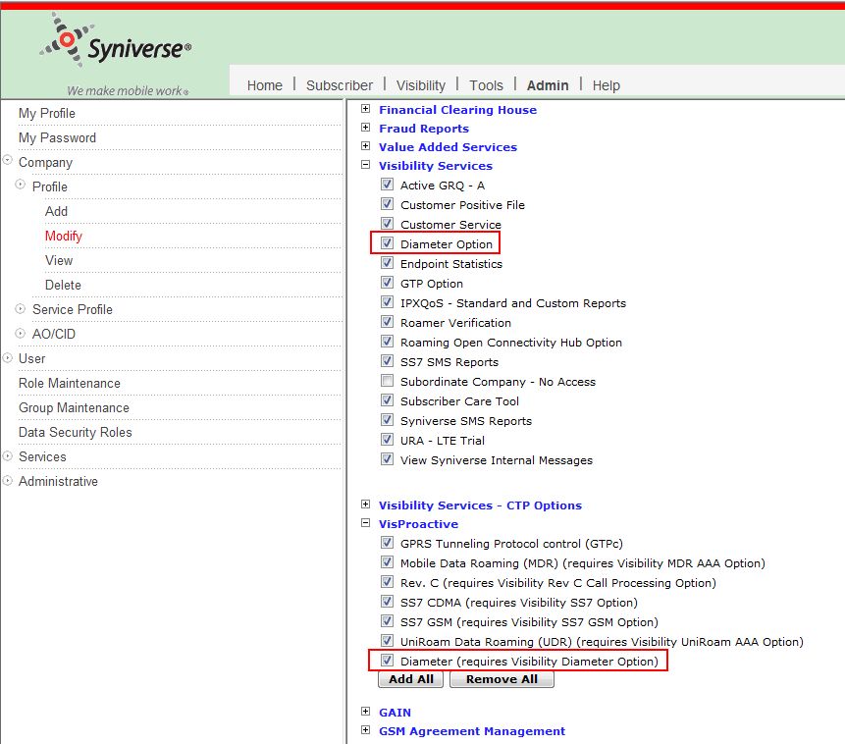

### Syniverse User and Non Syniverse User

For a Syniverse User or Non Syniverse User, please assign all these user permissions OR pick a user who already have the red marked permissions:

The red marked permission “Alert Pod” and “Heat Map Pod” under **“VisProactive - Diameter”** will bring “Alert Pod” and “Heat Map Pod” link respectively

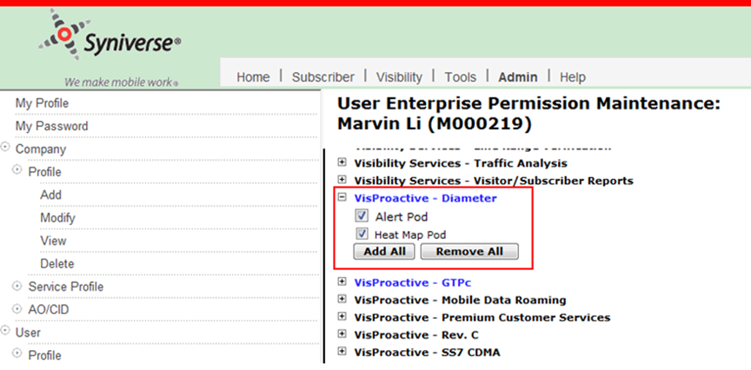

This user should see these links under **Visibility** tab. Logically all the links should be clicked and verified if they are showing properly or not.

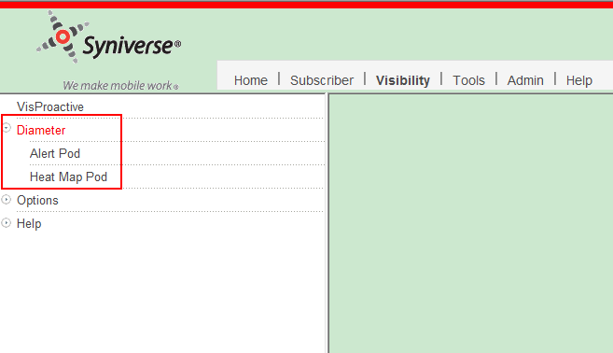

# Test Procedures

Centralized Testing has created a system test plan and executed it in the System Test environment. Please see their documentation and completion report for more information.